7.59: a) The kinetic energy of the potato is the work done by gravity (or the potential energy lost), 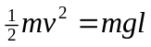, or .
b)
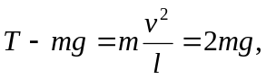

so

